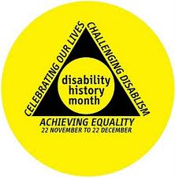
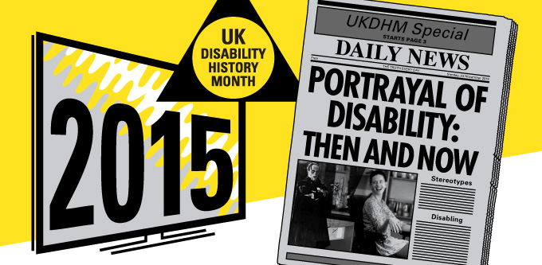

BROADSHEET : MOVING IMAGE PORTRAYAL OF DISABILITY: THEN AND NOW!
Has the way disabled people are shown in the media improved in recent years? Yes There are more stories about disabled people shown in less old fashioned ways on tv and film.
On Television-Carrie Mathieson in Homeland and Tony Soprano both with mental health issues. Monk, the detective with compulsive behaviour, Doc Martin with the same condition and a fear of blood.
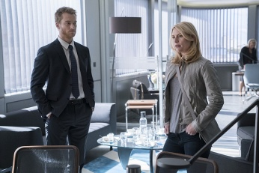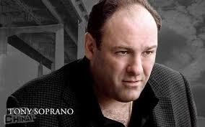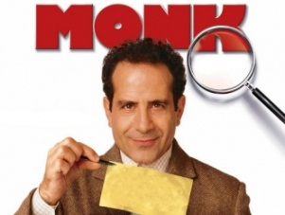
There has been more disabled actors playing disabled characters in soaps, and dramas. Sandy Richardson in Crossroads used crutches and a wheelchair, Julie Fernandez (wheelchair user) in Eldorado and Adam Best in Eastenders and then by Donna Yates (short stature and wheelchair user. Kitty Mc Geever (blind) was in Emmerdale, and Kelly Marie Stewart (wheelchair user) Hollyoaks. Cherylee Houston also wheelchair user is in Coronation Street. Liz Carr is in Silent Witness. American series have cast more disabled actors playing disabled parts, Paula Sage (learning difficulties) is in Afterlife; Peter Drinklage ( restricted growth) is in Game of Thrones; R J Mitte (cerebral palsy) is in BreakingBad. PushGirls shows four disabled women.
.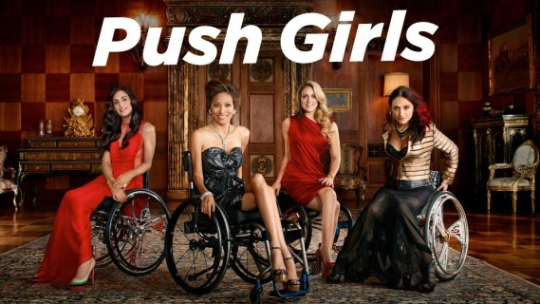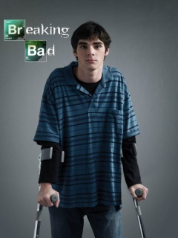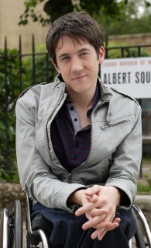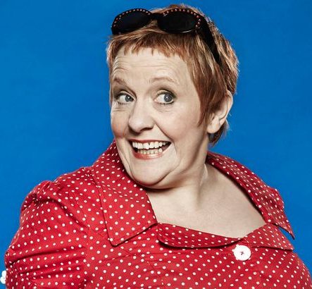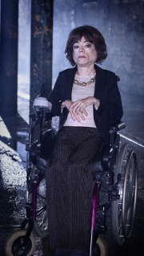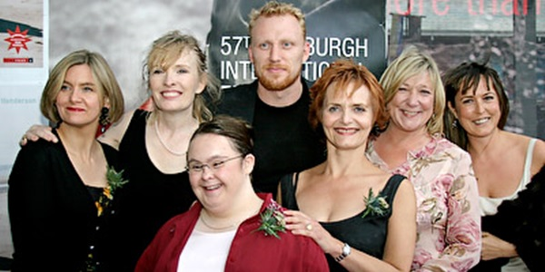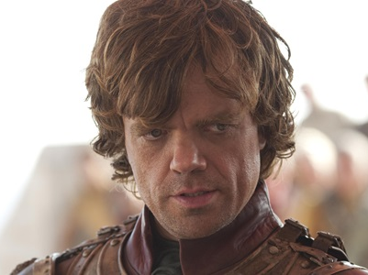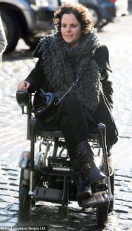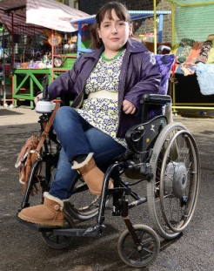
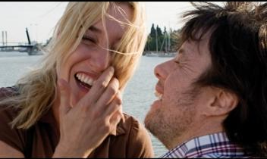
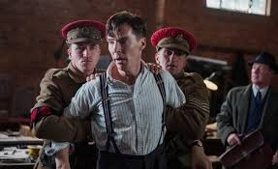
Film- Untouchable tells the story of spinally injured French business man and his black, rap loving support worker, became the highest money making non-English language film. My Name is Khan (2010) , Adam (2009), Mozart and the Whale (2004) all had interesting story lines around Aspergers’ Syndrome. The Sessions (2012) where Helen Hunt plays a sex therapist helping Mark O’Brian (quadraplegic) played by John Hawke to have and enjoy sex for the first time at 38. O’Brian’s story was real. In Rust and Bone (2012,) Marion About a recovering double amputee rediscovering life and her sexuality and Helped. Even in Avatar (2010, Dir . James Cameron) in which paraplaegic ex-marine, leads a mechanised revolution in his avatar form. The King’s Speech (2010) tells the true story of George the 6th and how he dealt with his speech difficulty; Hyde Park on Hudson (2012) which shows a meeting between George 6th played and F.D.Roosevelt and a discussion of how the public ignore disability in powerful men. Mary and Max (2008) an animated film that shows the life of 2 neuro- diverse people talking as pen pals. The Imitation Game (2014) brilliantly shows how neurodiverse and gay Alan, battles authority to break the Enigma Code. Theory of Everything (2014), not as successful biopic of Steven Hawking’s struggle with motor neurone disease, love and the universe. Margarita with a Straw (2014) tells the coming of age story of a Mumbai girl with cerebral palsy in India and New York. Yo Tambien-Me Too (2010) broke new ground by starring Pablo Pineda, a Spanish actor with Down’s Syndrome, struggling to find love, sex and independence. While the films talked about are mainly excellent films, in ‘Me Too’ the lead is disabled.
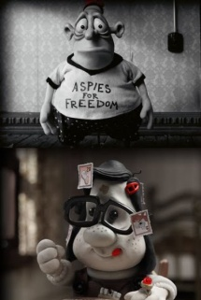
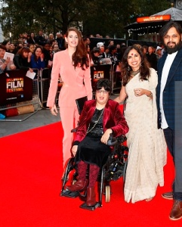
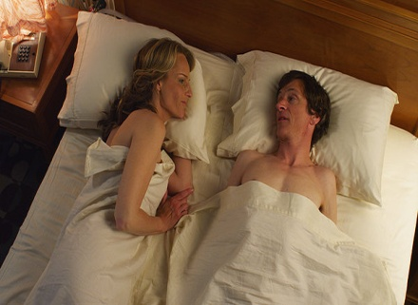
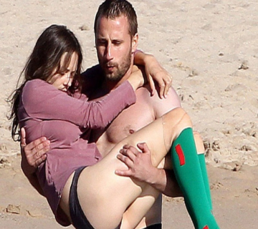

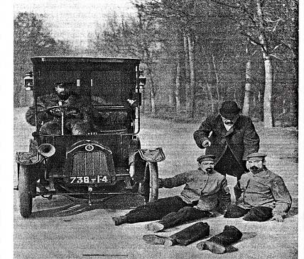
Showing disability can change attitudes and make them stronger. Despite what we show above improvements of showing disability in moving image media usually very incorrect. From the first silent movies, where disabled people featured as figures of fun, evil or pity, to the present day, when non-disabled actors portraying a disabled character receive Oscar nominations. Moving image media have failed to show the reality of disabled people's lives. The negative false images of disability, have become so familiar that people believe they show the reality of disabled people's lives. Many of the non-disabled audience accept these images with no questions because it is more comfortable to do that than to face their deep fear of difference. In 1898, Thomas Edison produced a film called "The Fake Beggar," its 50 seconds involving a man who pretends to be blind in order to beg for money on the street. (The scam is revealed when a policeman spots him bending over to pick up a coin. The policeman chases him. The picture on the left shows Automobile Accident with two actors made up the same-before and after being run over.
Disability in film is commonly viewed as being 'not normal' physically or mentally. Recently there have been more attempts to include us in film and more in TV mini-series & reality shows. Disability is an impairment of the body or mind caused by the loss or long-term non-functioning of a physical, sensory or mental part or system. Films usually show an individual response to disability, with the disabled person:-

- struggling to overcome their impairment;
- finding a cure;
- an object of pity;
- a passive victim;
- an object of curiosity/freak show;
- a figure of fun;
- a burden;
- having a chip on his or her shoulder and becoming an evil, aggressive avenger;
- triumphing over the tragedy of ’disability’;
- incapable of an adult/ sexual relationship.

This view of disability is known as 'medical model' thinking. There is another way, 'social model', which considers disability to be the organisational, environmental, social and attitudinal barriers that stop people with impairments being included in mainstream society. This view is not seen often in moving image media. Find out more about this at http://old.bfi.org.uk/education/teaching/disability/thinking/medical.html .We are hardly ever shown as ordinary, just there. We are 20% of the population, with the whole range of characteristics and interests as everyone else, but with additional barriers, needing acceptance or support and access to participate.
The UN Convention on the Rights of Persons with Disabilities (2006) agreed by the UK Government (2009) and 159 other countries around the world, is based on the social/human rights view of disability. It brings about a perfect example of the shift from seeing the problem in the person, to one of people with impairments being disabled by barriers that prevent them taking part on an equal basis. Article 8 Awareness requires Governments to “b) combat stereotypes, prejudices and harmful practices relating to persons with disabilities, including those based on sex and age, in all areas of life”- “Measures to this end include c) Encouraging all organs of the media to portray persons with disabilities in a manner consistent with the purpose of the present Convention”. http://www.un.org/disabilities/default.asp?id=268 The answer to stereotyping is to include us in all types of media as ordinary and diverse as everyone else.Traditional views Before the medical model, still spread around in many cultures around the world, is a traditional and/or religious approach in which people’s conditions were connected to magic, witchcraft, karma or punishment by a god/gods. People with physical, sensory or mental impairments were/are thought of as under the spell of witchcraft, possessed by demons, as penitent sinners, being punished by God for wrong-doing by themselves or their parents. Sometimes there are miracle cures. These ideas are constantly shown in films, TV, internet, books, newspapers and theatre. The impact of these ideas in the Old and New Testament were explored in the BBC Everyman drama documentary The Fifth Gospel,made by two disabled people. https://youtu.be/nbfW5dHAyng

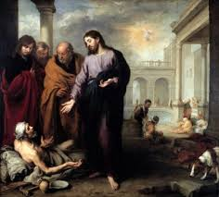
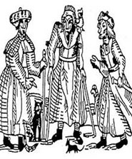
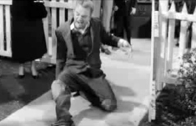

The man of thousand faces-Miracle cure
A medieval woodcut of witches Jesus miracle healing invalid Bethesda

Martin Norden identifies four eras in the representation of disability in moving image media in his book: The Cinema of Isolation: A History of Physical Disability in the Movies

First period: before World War 2 Disabilities are seen as freakish. One third of films made before 1919 featured disabled characters, mainly because of the visual appeal of difference in silent movies.
- The Automobile Accident is typical. A disabled actor and his non-disabled look-alike do a 'before' and 'after', as a car runs over his legs, leaving them separated from his body.
Another early comedy genre features faking disability.
- The Beggar's Deceit has a disabled beggar propelling himself along the pavement, begging for money and sympathy from passers-by, until a suspicious policemen taps him on the shoulder, at which he springs up and runs.

The characters Crettini (Italy), Borieau (France) or Foolshed (UK, USA) featured in at least a hundred films in the early 1900s, in which the audience laughs at someone with learning difficulties. After 1908, the reworking of many classic stories eg Treasure Island (USA 1920 Dir Maurice Tourneur; USA 1934 Dir Victor Fleming, ); The Hunchback of Notre Dame (USA 1923 Dir. Wallace Worsley); Frankenstein (USA 1931 Dir James Whale) led to physical impairments as the central part of the persons murderous behaviour .
After the First World War, many films featured cures to impairments which, in reality, were incurable. This was perhaps due to the increase in impairment caused by the War. From 1912 to 1930, there were 430 feature films with disability themes. Of these, 150 or 35% had characters whom eventually gain or regain the use of their sight, hearing, legs through corrective operations, God's will or sheer good fortune.
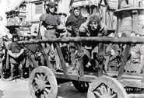
The enormous success of Lon Chaney is a good example of the rise of freakishness. He specialised in roles such as Blizzard, a gangster driven to evil by the loss of his legs in The Penalty ; Blind Pew in Treasure Island, Quasimodo in The Hunchback of Notre Dame, the Phantom in Phantom of the Opera , the Armless Wonder in The Unknown, and Dead Legs in West of Zanzibar. This led to a huge growth in the horror movie genre.
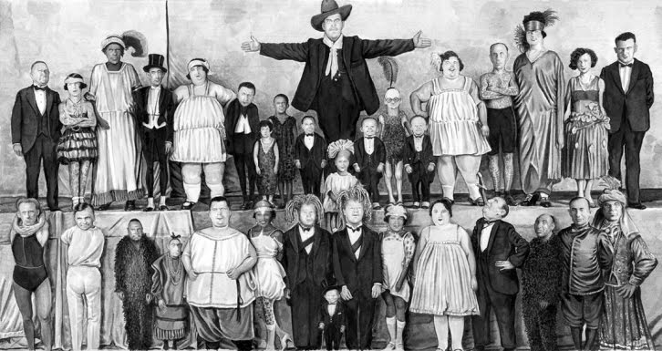
- The film Freaks (USA 1932) used real disabled performers from circus sideshows. The producer was told by the studio to 'top the horror of Frankenstein'. Now seen as a classic, Browning cast sideshow performers with physical deformities, and presented them as sympathetic members of a unique community of entertainers. The "monsters" in Browning's plot were two "normal" performers who humiliated the "freaks" while planning to murder one to get his inheritance.
Over this period, some of the enduring stereotypes of disabled people in film were established. http://old.bfi.org.uk/education/teaching/disability/thinking/stereotypes.html
- The 'sweet innocent' or pitiful character, A Blind Woman's Story ; Tiny Tim in A Christmas Carol .The Two Orphans
- The 'noble warrior' - showing disabled veterans and their problems with adjusting to life, The Four Horsemen of the Apocalypse , featuring a blind veteran; The Big Parade, in which a soldier who has lost a leg goes back to France to find his sweetheart; The Dark Angel - a love triangle with a shy, modest, blinded officer, who hides from his ex lover so his non-disabled friend can be with her.
- The 'obsessive avenger'; Long John Silver in Treasure Island; Captain Hook in Peter Pan; Captain Ahab in The Sea Beast. One commentator points out:
“From the first horror films to modern-day renderings, physical and mental disabilities have been shown to connote murder, evil, violence and danger”.

Second period: immediately post-World War 2 Films about disability become more rehabilitative. Many have plots revolving around returning veterans, some of whom were disabled. Became part of a wider movement to make films about social issues, these films did well at the box office. In the USA and Europe, the generation that had fought the War wanted their dreams for a more just society reflected in the films they made and saw.
- Pride of the Marines is based on the true story of Al Schmid, who was blinded by a Japanese grenade. He returns to the US feeling bitter, before family and friends convince him to shake off his self-imposed isolation. The film argues that people can't make it on their own and takes on issues of discrimination. Al's Jewish friend, Lee Diamond, says:
“Sure, there'll be guys who won't hire you even when they know you can handle a job. There's guys that won't hire me because my name is Diamond instead of Jones. Cause I celebrate Passover instead of Easter. Do you see what I mean? You and me, we need the same kind of world; we need a country to live in where nobody gets booted around for any reason”. However, Al remains an isolated character, and unrealistically begins to recover his sight in the end.
- Till the End of Time is about three ex-marines, two of them disabled, changing their attitudes to themselves.
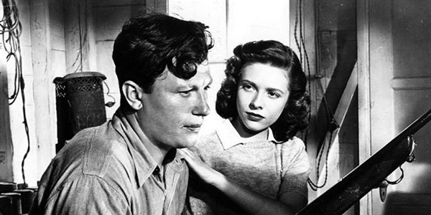
- In The Best Years of Our Lives , non-professional actor, Harold Russell, who lost both hands in the War, won two Oscars: one for acting and one for bringing hope to ex-servicemen. Through a mixture of subjective and objective shots, director Wyler avoids a pitying reaction to Russell's character, Homer Parish, and subtly shows him getting back together with his girlfriend Wilma, not through pity, but through love. An early Realistic Portrayal.
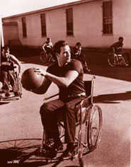
These were followed by Home of the Brave; The Men with Marlon Brando giving a fine subtle performance but not feeling able to carry on with his marriage and Bright Victory, all in a similar vein. This concern with wider social issues, but still only featuring individual solutions, is reflected in films, such as: Alfred Hitchcock's Spellbound, which uses subjective or 'point-of-view' shots, flashbacks and a dream sequence designed by Salvador Dali to portray mental health impairment. The suspense comes from psychoanalyst, Ingrid Bergman, in love with Gregory Peck, who may be a killer but being an amnesiac, can't remember. This has strong similarities to the techniques used in The Lost Weekend, which tackled the taboo subject of alcoholism.

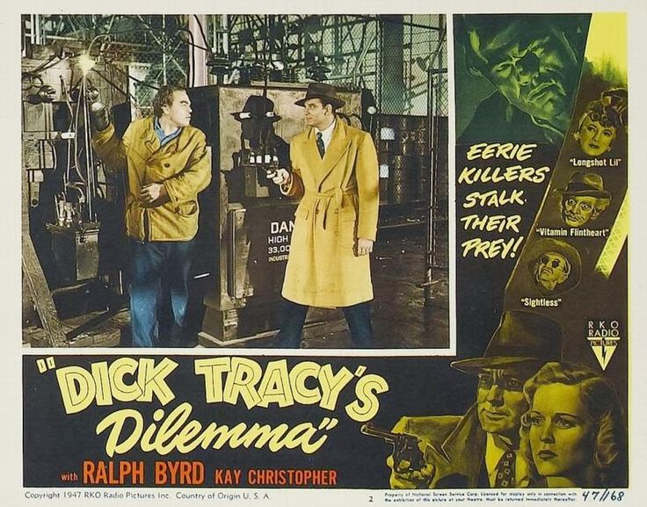
The old stereotypes still feature strongly in, for example:
Dick Tracy's, based on Chester Gould's comic strip. This film shows the clean-cut, non-disabled Tracy with 'the Claw', a fur thief who kills people with his prosthetic hook. According to Tracy, the Claw got his hook when a coastguard cutter rammed him during illegal operations in the Prohibition. When eventually the private eye tracks the Claw down in an electrical substation, he raises his hook to strike the hero and touches the electrical apparatus, electrocuting himself.
Third period: from the 1950s to late 1960s The portrayal of disabled people in films becomes even worse. This backwards move was given strength by the McCarthy 'witchhunts' in the USA, when many filmmakers were forced to attend the House Un-American Activities Committee to identify their friends as disloyal to the USA. Nearly all left-wing filmmakers and actors were accused of being Communists and barred from working. People responsible for the films with social comment that came out at the end of the War were blacklisted and the Studios in Hollywood went into self-censorship mode. This meant going back to a range of movies influenced by the former stereotypes. A rash of films about civilian disabled people overcoming their impairment were made,
- Bad Day at Black, was a Western, in which Spencer Tracey played the mysterious one-armed man Alone and unaided, he acts the stereotype of 'super-crip', as he uncovers what happened to Japanese Americans during World War 2 in the town.
- In the UK, Kenneth Moore played Douglas Bader in the unabashed 'triumph over tragedy' 'bio-pic', Reach for the Sky.
- Sunrise at Campobello follows F.D. Roosevelt from contracting polio, to walking ten steps, to making a speech to launch his political career. The reality was that Roosevelt carries out his Presidency from his wheelchair, although he hid this from the American people.
- The Miracle Worker about deaf-blind Helen Keller learning to communicate with the help of Annie Sullivan, also shows a disabled person 'triumphing over tragedy'.
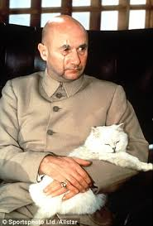
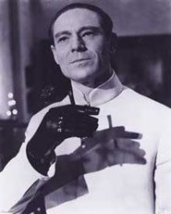
This stereotype makes disabled people feel they can only be accepted if they prove they are better than non-disabled people, and it encourages the view that disabled people are of little value unless they behave like 'super-crips'.
1962 saw the beginning of the stereotypical featuring of disabled baddies in the extremely popular James Bond films.
Dr No featured the mad Dr No with his two false hands. This has continued with baddies in Bond being physically or mentally disabled e.g Blofeld, Jaws, Boris. Other films followed this example:-
Dr Strangelove featured Peter Sellers as the mad, wheelchair-using, ex-Nazi scientist advising the President as the world moves toward nuclear destruction.
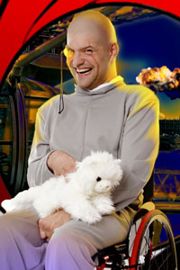
Hollywood also recycled some of the best-known classic stories featuring characters with impairments, using fear:
- Peter Pan, featuring disabled Captain Hook, was remade as a Disney cartoon.
- Treasure Island, with Long John Silver and Blind Pew, was remade for the sixth and seventh times.
In Britain, Hammer Horror movies pumped out a steady stream of films featuring disabled anti-heroes. Laurence Clarke in a recent blog examines how disability and evil are continuously linked. http://www.bbc.co.uk/ouch/opinion/12_evil.shtml

Fourth Period: since the late 1960s to 2003 There is a swing to a more enlightened, tolerant stance, linked in the USA to the returning Vietnam War veterans and, in Britain, to a left-wing liberalism in the film industry. Audiences for films featuring aspects of disability were large enough to encourage filmmakers to produce a stream of such films over the next forty years. They mainly feature civilian disabled characters who sometimes go beyond the earlier stereotypes, while reinforcing others. Some examples are:
- The Heart is a Lonely Hunter (USA 1968), features several deaf characters, including Singer (Alan Arkin), the main one. He is also shown as isolated, a saintly wise man, but he does help out a whole range of other characters. The film is based on a novel by Carson McCullers, whose books tend to be more concerned with the grotesque.
- Midnight Cowboy (USA 1969) features John Voight as the Texan cowboy in New York and Dustin Hoffman as the physically impaired and tubercular Ratso Rizzo. Ratso has lived on the streets for years has a limp and he befriends and mentors the cowboy before dying.
- Tell Me That You Love Me Junie Moon (USA 1970) tells the story of three disabled people coming out of an institution, setting up home together, and their adventures in relationships involving race and sexuality.
- The Ballad of the Sad Café (UK-USA 1991), another Carson McCullers adaptation, features a powerful matriarch (Vanessa Redgrave) who, through her general store and café, holds her hometown in the palm of her hand. Her life is disrupted by her returning ex-con husband, with whom she fights. Cousin Lyman, a short ‘hunchback’, also visits. In a totally unrealistic scene, Cousin Lyman swoops down on the feisty Redgrave as if flying, and thereby breaks her spirit.
However, negative representations of disabled characters echoed past portrayals. There are several examples in films adapted from comic books:
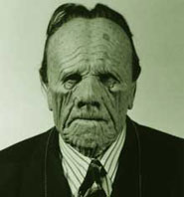
Dick Tracy (USA 1990), in which all the baddies sport impairments: Al Pacino as Big Boy has a hunchback, Dustin Hoffman mumbles with a speech impairment, and many others have facial disfigurements: Pruneface, Shoulders, Stooge, The Rodent, The Brow, Little Face and No Face (this last being Breathless Mahoney –(Madonna ) disguised to take control of the city). Batman (USA 1989), the Penguin; or Batman Forever (USA 1995), the Riddler or Harvey Two Face - one side bad, one side good.
Euthanasia-The ongoing pre-occupation with euthanasia, or 'the life unworthy of life' featured in a number of films in this period, such as:
- Johnny Got his Gun (USA 1971), based on his 1939 anti-war novel and shot almost entirely from the character, Joe's, viewpoint. Only slowly do the audience realise that Joe has no limbs or face, nor can he hear, see or speak, having been hit by a shell on the last day of the First World War. Eventually, by banging his head in Morse code, Joe gets one of the nurses to convince the doctors he is not a 'vegetable', but they will not concede to his request for death.
- A Day in the Death of Joe Egg (UK 1971), in which a young English couple struggling to raise a disabled child contemplate 'mercy killing'. It is given a darkly humorous treatment.
- In Whose Life is it Anyway? (USA 1981), a paralysed sculptor wants to die after he learns that the injuries he sustained in a car accident are permanent. The judge decides he can grant his request.
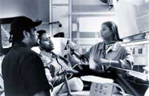
The Bone Collector (USA 1999). At the beginning, Rhyme (Denzel Washington), a top New York detective who sustained a major spinal injury four years earlier, wants 'a final adjustment', enlisting a doctor friend to help. When he gets involved in solving a series of murders with a young detective (Angelina Jolie) the killer tries to kill him, he fights back with all his ingenuity. The film ends with a hint that he and Jolie are starting a relationship, all thoughts of euthanasia gone.

A number of films stand out as memorable for the sympathetic approach taken by the filmmakers to their disabled subjects. The films below are all examples of more enlightened moving image portrayals.
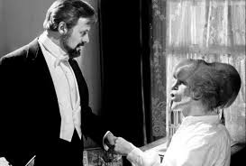
A powerful film evoking feelings of pity, The Elephant Man (UK 1980) was shot in black and white. It tells the true story of David Merrick, who had a very rare condition that led to huge growths on his skull and face and scoliosis (curvature of the spine). He is shown as a side-show freak in Victorian London. He's rescued by Dr Treves (Anthony Hopkins) of the London Hospital, who offers Merrick a home and exploits him in a different way, as a medical curiosity. John Hurt, who plays Merrick, brings out the humanity of the character by singing, reciting psalms and his perfect manners. This gives him the air of a saintly sage. Merrick continues as a freak today - he is still preserved in formaldehyde in the London Hospital for viewing by medical students.
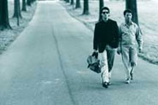
Rain Man (USA 1988) won many Hollywood accolades. It features the selfish, greedy Charlie Babbit (Tom Cruise) and his autistic elder brother, Raymond (Dustin Hoffman), whom Charlie did not know existed until his father died and left $3 million in trust for Raymond. Raymond lives in an institution and Charlie takes him out on a cross-country journey, hoping to persuade Raymond to give him half the money. Raymond's many autistic tendencies (unlikely to be found in one autistic person) include rigid and unchangeable habits, which Charlie is forced to accommodate. Charlie is forced to reassess his own life.
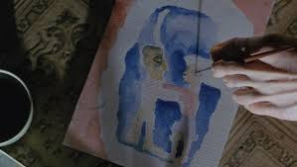
My Left Foot (UK 1989) is based on the life-story of Christy Brown, who had cerebral palsy and wrote his story with his left foot. The film is set in working-class 1950s and 1960s Dublin and shows Christy learning to write and paint with his left foot. He is shown as witty, angry, drunk and frustrated. The film also shows the powerful impact of parents, particularly mothers (Brenda Fricker), when they believe in and support the potential of their disabled children against a negative world. In My Left Foot, Christy was played by Daniel Day Lewis. A method actor, Day Lewis spent months with disabled people in a wheelchair, twisting his body and learning to paint with his foot, before filming began. The paintings in the film were all done by Day Lewis using this method. When the film came out, disabled people raised the issue of casting, saying that Christy should have been played by an actor with cerebral palsy. However, it is unlikely that without Day Lewis, this film would never have been made. As this was an excellent portrayal, it did raise awareness amongst the general public.

All these, plus others, such as Gaby - A True Story (USA-Mexico 1987 Dir. Luis Mandoki), about the struggles for inclusion of a girl with cerebral palsy; The Waterdance (USA 1991 Dir. Neal Jimenez/Michael Steinberg), was written as well as directed by Jimenez, a wheelchair user, and based on his experiences in a rehabilitation hospital; Passion Fish (USA 1992 Di.r John Sayles), about the personal change impairment brings; Philadelphia (USA 1993 Dir. Jonathan Demme), which dealt with HIV/AIDS in a sympathetic manner, are evidence of a more enlightened attitude, though the problem of disability is still seen as an individual one.
Some films, following One Flew Over the Cuckoo’s Nest (1975 Dir. Milos Foreman), have broken new ground by showing a sympathetic approach to mental health:
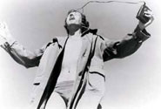
Shine (Australia 1996 Dir. Scott Hicks) tells the true story of David Helfgott (Geoffrey Rush). He's an Australian piano prodigy with a history of mental health issues, driven by his overbearing father, who was a concentration camp survivor. The film shows Helfgott's journey back to piano playing, supported by his love of Gillian (Lynn Redgrave).
A Beautiful Mind (2001, Ron Howard, USA) is about the mathematician John Nash (Russell Crowe), and shows how his mind is taken over by delusional figures. It follows his lifelong personal battle to co-exist with them and still carry on with his mathematics.
However, bad habits continue. One unfortunate trend that emerged in the 1990s was for a main character to pretend to be disabled elicit the usual response from other characters:
The Usual Suspects-Kevin Spacey's character (USA 1995 Dir. Bryan Singer) has cerebral palsy and is ignored by his gang. He tells, in flashbacks, an amazing story featuring an underworld boss, who turns out to be himself as he really is - not disabled. This flaws one of the cleverest, best-acted and most influential thrillers of the 1990s, relying upon the usual responses of the rest of the gang and the police.
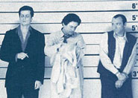
Lee Evans in There's Something About Mary (USA 1998 Dir. Peter Farrelly/Bobby Farrelly) pretends to have cerebral palsy to get Mary's sympathy. This was somewhat offset by the inclusion of Mary's brother and friends as people with learning difficulties, played by people with learning difficulties, and Danny Murphy, a wheelchair user.
- In The Score (2001, Frank Oz, USA) a young man (Edward Norton) sets up a robbery in the Custom House, by pretending to be a cleaner with cerebral palsy to make him seem innocent to the guards. He double-crosses his partner, the more experienced and older thief (Robert DeNiro), who was persuaded by his 'fence' (Marlon Brando) to work with Norton in his home town of Montreal, although both things break his 'rules'. However, experience wins out in the end.
Cure, death, vengeance, humor and tragedy have continued as themes right up until the present day, often in entertaining and otherwise well-made films:
See No Evil, Hear No Evil (USA 1989 Dir. Arthur Hiller) encourages the audience to laugh at a blind and a deaf man (Gene Wilder and Richard Pryor) and their misadventures.
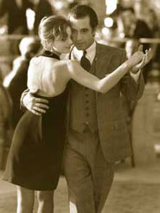
Scent of a Woman (USA 1992 Dir. Martin Brest) features blind ex-Colonel, Frank Harris (Al Pacino) driving across New York at speed and wanting to kill himself. His friendship with a young man (Chris O'Donnell) shakes him out of his self-indulgence.
Unbreakable (2000, USA). At 6 feet 2 inches, Sam Jackson unbelievably plays a man with brittle bones, called Mr. Glass (people with brittle bones do not grow to anywhere near this height). He is obsessed with comics and their indestructible super-heroes and anti-heroes. He transfers this obsession to his own life, seeking out his complete opposite in the 'unbreakable' Bruce Willis character. Mr Glass plans all sorts of murderous mass accidents to try to find and break him. The filmmaker also fails to convince you that the Willis character is 'unbreakable'.
- Red Dragon (2002,, USA/Germany), in which the hare-lipped, isolated protagonist with a chip on his shoulder, Francis Dolarhyde (Ralph Fiennes), is a multiple murderer of whole families. Throwing in a blind woman who unknowingly has a relationship with the killer, this formulaic thriller reinforces these old stereotypes in a new Millennium.
- Daredevil (2003, USA) is a sci-fi action thriller, based on a Marvel Comics character. Mathew Murdock (Ben Affleck) is the blind lawyer devoting himself to bringing wrongdoers to justice, since his father was killed by gangsters. Murdock is blind after being struck by a truck, but no-one knows that he was also covered in unusual radioactive chemicals, raising his other senses to such a keen pitch that they act like radar. This reinforces the wrongly-held idea that blind people have developed some sixth sense, but does at least show a disabled person as a super-hero. This compensatory 'super-crip' stereotype is not unusual in films based on comic books, such as Hulk (2003,USA); or X-men (2000,USA).
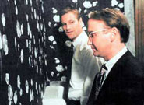
In the Company of Men (USA 1997 Dir. Neil LaBute). Passed over for promotion and dumped by their girlfriends, Chad and Howard want revenge. Out of town for six weeks on a business trip, they fix on beautiful, deaf Christine, who works in the typing pool, as their victim. They get her to fall in love with one of them by trickery and then drop her, destroying her fragile self-confidence. Though much praised by the critics, it is worth considering the negative impact this film must have had, on reinforcing people's view of disabled people as victims.
The Disney organisation has continued its long tradition of reinforcing negative stereotypes of disability, eg in Peter Pan (USA 1953 Dir. Hamilton Luske/Clyde Geronimi/Wilfred Jackson) with vengeful Captain Hook; and Snow White and the Seven Dwarfs (1937), the dwarfs being figures of fun isolated in the forest. Disney then took Victor Hugo's classic, Notre Dame de Paris and produced:
- The Hunchback of Notre Dame (USA 1998 Walt Disney). In this cartoon, Disney chose to have Esmeralda go off with the non-disabled Phoebus rather than the hunchback, Quasimodo, who loves her. Quasimodo has to go off with a little girl. In the 6 months after this came out people with scoliosis were attacked and name called ‘Hunchback’ .
Mr Magoo, the visually-impaired man who is a figure of fun, was made into a full-length cartoon feature film by Disney in 1997, but this flopped. The Hunchback of Notre Dame II (2002, Walt Disney, USA) was only released as a video. These failures and straight-to-video films suggests this type of film is becoming less popular.
Science Fiction allows filmmakers to play around with what is meant by 'normality'.
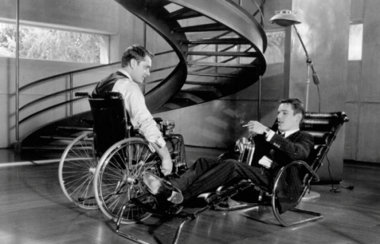
- Extreme Measures (USA 1996) is a thriller with science fiction elements about an ambitious and selfish Doctor Myrick who is seeking a cure for spinal injury by experimenting on live homeless people. Various wheelchair users go along with his plan. A young trauma room doctor, Luthan (Hugh Grant), becomes suspicious and uncovers the plot, putting his own life in danger.
- Gattaca (USA), which is set at some point in the future when everyone is genetically designed, Vincent (Ethan Hawke) is an outsider of natural birth, called an 'In-valid'. Determined to break free of his genetic destiny, Vincent meets Jerome (Jude Law), a 'Valid' who has sustained a spinal injury, uses a wheelchair and is prepared to sell his genetic material for cash. Vincent uses Jerome's hair, blood and urine samples to forge a new identity. This is a reminder that even in a genetically 'cleansed' future, with all the impacts on human life and freedom shown in the film, impairment is part of the human condition.
- X-Men (2000, USA) is based on the Marvel Comics characters, featuring Professor Charles Xavier (Patrick Stewart), a wheelchair user and genius telepath, who runs the 'good' mutants. Magneto (Ian McKellen) is his enemy, and a mutant who wants to eliminate humans. The mutants are able to manipulate aspects of the environment or people with their supernatural powers. In X2 (2003, USA), an attempt is made to eliminate all mutants by Stryker (Brian Cox). While Stryker is trying to destabilise Xavier's mind through a medium, he makes him hallucinate that he can walk so further eroding his identity as a disabled person. The good Doctor Xavier prevails and co-existence is assured between mutants and humans.
Disabled people as ordinary- There are now many more moving image media which include characters who are disabled people in an incidental way, without stereotypes. Some from Hollywood are:
- Fried Green Tomatoes (USA 1991), features an old woman in a wheelchair who takes the audience back with her memories. A young boy in the flashbacks loses his arm in a train accident without this having any real plot significance, other than acknowledging that accidents which cause impairment can occur at any time.
- The Fisher King (USA 1991), which deals with mental illness and depression in a matter-of-fact manner.
- ER - The Emergency Room, TV series that has for 12 years featured a disabled senior doctor who uses a crutch, Dr Kerry Weaver. Apart from an early episode, this has not been remarked upon or used for dramatic effect. She's just there, along with a number of disabled users of the hospital.
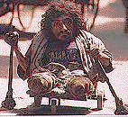
- Clear and Present Danger (USA 1994), in which Jack Ryan (Harrison Ford), CIA Assistant Director, is supported by a minor character in the office who is a wheelchair user. Hardly worth a comment, if it wasn't so uncommon for a wheelchair user to be included without any other plot reason.
However, more films featuring non-stereotyped disabled characters have been made away from Hollywood, such as Shine .
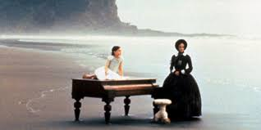
- City of Joy, (USA-UK-France 1992), set in a Calcutta slum, where disabled actor, Nabil Shaman, gives an excellent supporting performance.
The Piano (NZ-UK-USA 1993 Dir.Jane Campion) featuring a Scottish woman (Holly Hunter) with a speech impairment, who travels to New Zealand for an arranged marriage with a landowner (Sam Shepherd). She is subjected to cruel sexism and disabilism by him and finds comfort in a bizarre erotic relationship with a character played by Harvey Keitel.

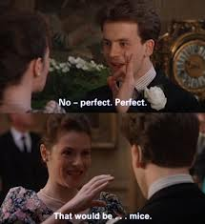
- Langer Gang (Corridor) (Germany 1993 ). In spite of being set in an institution, the people living there (disabled people with physical impairments) conduct their lives with passion and commitment at night in the corridors. All the actors are disabled. They cope with their physical limitations, but also with their rage about the barriers these impose these impose, and difficulties in dealing with the relatively clueless 'whole' people who administer the Centre. They also manage skilfully to get every ounce of enjoyment out of life, in quite surprising ways. This movie has many disturbing scenes, some of them of an obviously sexual nature. It tells the tales of the individuals in it with a humour and honesty which is free from the sentimentality usually associated with such stories. The director himself once resided at such a Centre and is a disabled filmmaker.
- Four Weddings and a Funeral (UK 1994), in which the Hugh Grant character's brother is deaf and played by a deaf actor (David Bowyer).
- Scallagrigg (1994, BBC TV), telling the story of a boy with cerebral palsy put in a mental handicap hospital, and some young disabled people's search for him 60 years on.
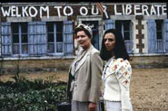
Antonia's Line (NL-Belgium-UK 1995), about three generations of women and the community Antonia builds around her, including two people with learning difficulties who have a relationship, have sex and get married.
Go Now (UK 1995) is a vibrant, unsentimental comedy drama of a young man who discovers he has multiple sclerosis, and of the woman who loves and supports him. As his impairment gradually develops, Nick (Robert Carlyle) is unable to engage in male bravado and sport. He gets depressed but comes through it to find a new way of relating to Karen.
- Live Flesh (Spain/France 1997 Dir. Pedro Almodòvar) has a wheelchair-using detective whose adjustments are shown well, but whose wife has sex with the criminal who had shot him and made him a paraplegic.
- Orphans (UK 1997 Dir. Peter Mullan), in which one of the three siblings is a wheelchair user, which is incidental to her role in this dark comedy.
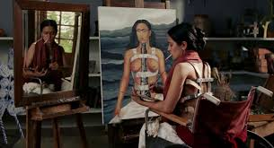
- The Theory of Flight (UK 1998 Dir. Paul Greengrass) tells an unlikely tale of a artist (Kenneth Branagh) on community service with Jane ( Helena Bonham-Carter), who is a wheelchair user with a progressive neuro-muscular condition. Jane wants to lose her virginity 'before it's too late'. Mawkish at times, at least it recognises that disabled women have sexual feelings.
Iris (2001, Richard Eyre, UK/USA) is a sympathetic film about the writer, Iris Murdoch (Judi Dench) and her degenerative impairment of Alzheimer's disease. It is not sentimental, just an excellent realistic recognition of the disease.
Frida (2002, USA/Canada) brilliantly tells the story of artist Frida Kahlo (Salma Hayek) from before her accident, which leaves her permanently impaired, to her death 30 years later. Throughout, Kahlo's art, which reflects her feelings as a Mexican, a woman, a socialist and a disabled person, is shown in the context of its creation.
The Lost Prince (2002 BBC) featured the Queen's uncle, John. It is a sympathetic view of John, who had epilepsy and was shut away on a farm in Norfolk until his death at thirteen, because of ongoing prejudices and fears that the public might view the Windsor blood line as tainted.
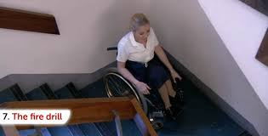
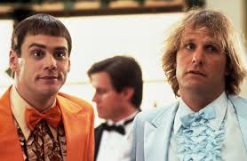
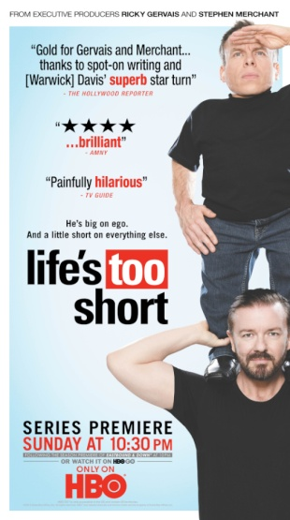
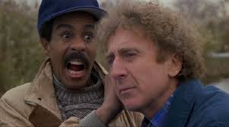
Disabled people as humorous. The trend to use disability for shallow shocks and gags continued from 1908's "Don't Pull My Leg" , a presumably comic tale about a stolen prosthetic leg , up to and beyond 1989's "See No Evil, Hear No Evil," with Richard Pryor and Gene Wilder straining to get laughs from their portrayed visual and hearing impairments. The Farrelly brothers in particular have disabled characters in many of their films such as Dumb and Dumber (1994), Kingpin (1996), There’s Something About Mary (1998), Me, Myself & Irene (2000), Stuck on You (2003) and The Ringer (2005). They often have supporting actors who are disabled people but the aim of these films is primarily to laugh at disabled people. The Farrelly brothers may think they are improving understanding. However, they are encouraging the view, especially with young audiences that it is alright to make fun of disabled people. It starts with jokes at the victim’s expense, leading on to exclusion from social situations, and can lead to hate crime with violence and ultimately death. A recent survey by the Anti Bullying Alliance, found that 85% of young people aged 18 to 25 thought it was OK to call disabled people ‘mong’, ‘spastic’ and ‘retard’. All offensive words to disabled people. The Equality and Human Rights Council found that hate crime in the community and bullying at school to disabled people is on the increase.
Some non-disabled comedians, such as Ricky Gervais, The Office, Extras , Life’s Too Short (with Warwick Davis) , Derek maintain that it is ironic to make fun of disabled people and it is just comedy. He is funny, but if it puts people down so they feel bad about themselves and it encourages others to do this, it is harmful.

The 2010 BBC TV documentary ‘Are You Having a Laugh’ ( disabled Dir.Kate Monaghan) encouraged this point of view, was supported by some disabled people but opposed by others. Since 2010, Government cutbacks on disabled people’s benefits, with encouragement to the press to falsely maintain that many disabled people are fraudulent and scroungers, have encouraged abuse and hate crime.
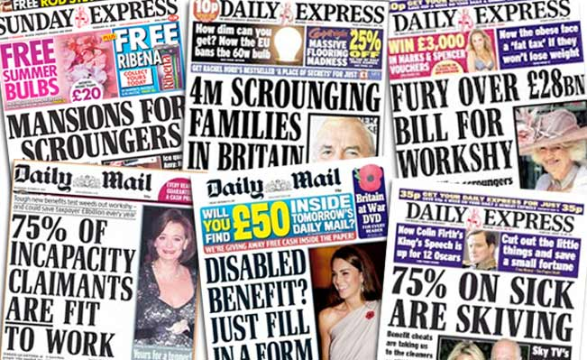
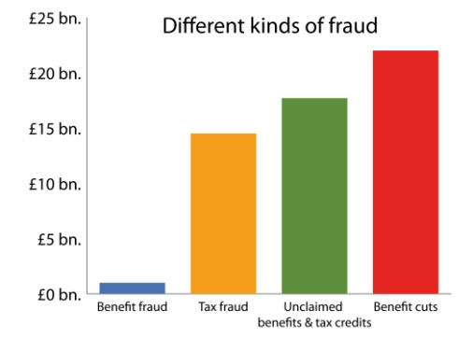

Progress in TV Drama
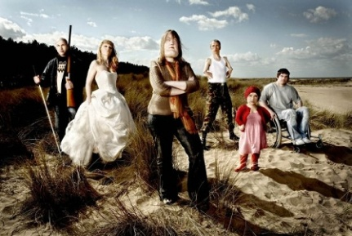
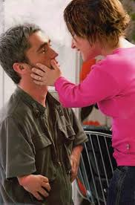
A few TV programmes which have included disabled actors present a much more realistic and subtle presentation of the issues disabled people face.

Every Time You Look at Me BBC (2004) featured disabled actors Mat Fraser and Lisa Hammond in which they are the leads in an excellent drama which includes serious relationship issues.
Cast Offs Ch4 (2015) a dark comedy drama which exams interactions of 6 disabled actors with different impairments in a spoof reality show, when placed on an island for 90 days. For each their back story is covered.
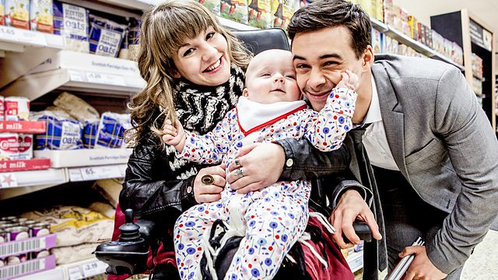
Don’t Take My Baby Ch4 (2015) An excellent docu-drama on the fraught issue of Social Services taking away the children of disabled parents, played by disable actors

We should bear in mind the words of Allan Sutherland who in 1993 wrote
"that the very fact that previous representations of disability have been narrow, confused and unimaginative leaves the way open for disabled writers and film makers. What we can produce can blow the past away."
As some films and TV programmes come to grips with good story lines and involve disabled people in front and behind the camera now is a good time to move forward. The best way to improve portrayal is to get more disabled people working in all roles in the media industry.

Resources to raise discussion and understanding. http://ukdhm.org/resources/2015-resources
Social Model http://old.bfi.org.uk/education/teaching/disability/thinking/medical.html
UN Convention on the Rights Persons with Disabilities http://www.un.org/disabilities
Stereotypes http://old.bfi.org.uk/education/teaching/disability/thinking/stereotypes.html
http://worldofinclusion.com/v3/wp-content/uploads/2014/01/disability_in_media.pdf
Film Clips for use in discussing disabling imagery http://ukdhm.org/portrayal-in-film/
Disabling Imagery http://ukdhm.org/disabling-imagery/
Off Limits Images of Disability http://ukdhm.org/off-limits-images-of-disability
Raspberry Ripple Awards 1997 for best and worst portrayal http://ukdhm.org/raspberry-ripple-awards/
Broadcasters Network http://www.ofcom.org.uk/static/archive/itc/uploads/Make_A_Difference.pdf
International Labour Organisation Reporting on Disability Guidelines for the Media http://www.ilo.org/skills/pubs/WCMS_127002/lang--en/index.htm

National Coordinator UK Disability History Month, 78, Mildmay Grove South, London N1 4PJ
e.mail info@ukdhm.org Website www.ukdhm.org Accessible format of this Broadsheet on website

